**User Stories**

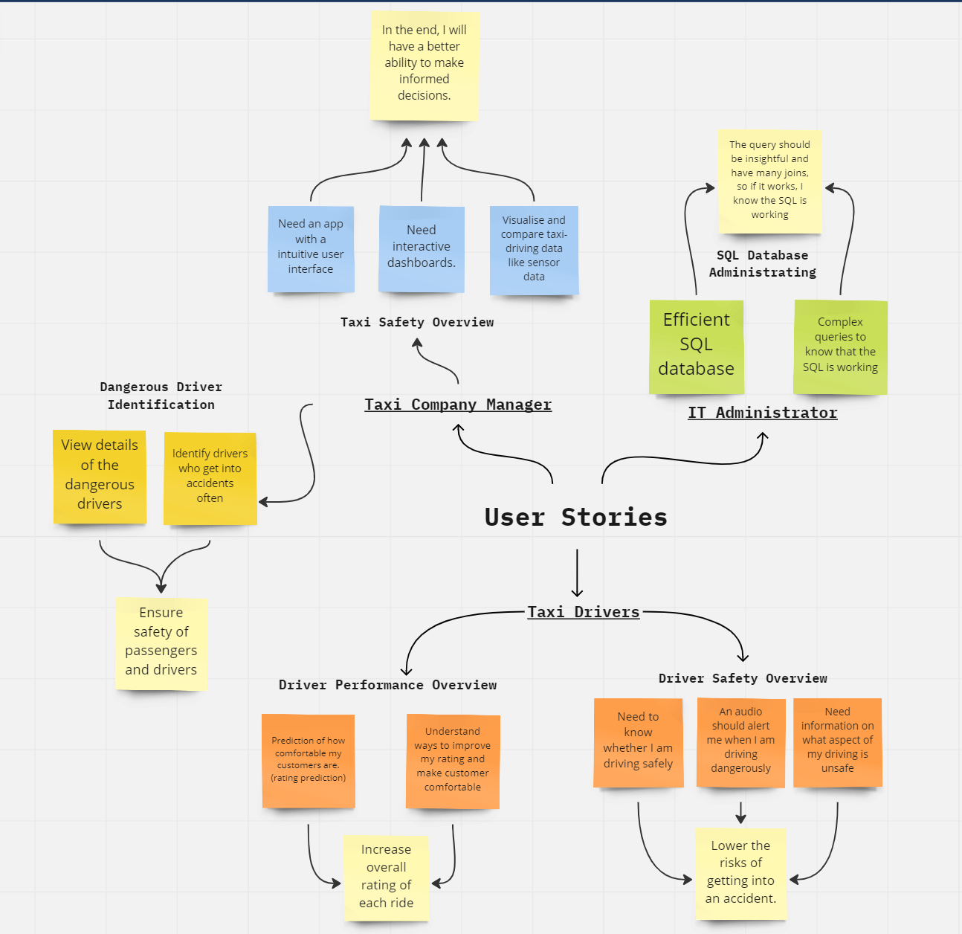

*Figure 1: Overview of Dashboard Drillthrough*

|  |
| --- |
| **User Story Card 1: Taxi Safety Overview**  As a Taxi Company Manager,  I need an application with a intuitive user interface which allows me to visualise, analyse and compare taxi-driving data such as the telematics data on trip safety. I also expect the dashboards to have interactivity, when I hover over elements in the dashboard, it should provide me more relevant information. In the end, I will have a better ability to make informed decisions. |

|  |
| --- |
| **User Story Card 2: Dangerous Driver Identification**  As a Taxi Company Manager,  I need to know who are the drivers that are most prone to getting into accidents so that I can swiftly deal with the issue. I want to see detailed information of the drivers, like their average driving speed and customer rating so I can see how to improve from there. This allows me to be able to guarantee the safety of the passengers more easily. |

|  |
| --- |
| **User Story Card 3: SQL Database Administrating**  As an IT Administrator,  I want an efficient SQL database that I can painlessly manage to improve my work efficiency. I would need MSSQL implementation so I can manage the security and permissions of the database more easily. It will also allow for easy backups of the database in case of failures/reverts. |

|  |
| --- |
| **User Story Card 4: Driver Safety Information**  As a taxi-driver,  I need to know whether I am driving safely so I can lower the risks of getting into an accident. An audio should alert me so that I am aware when I must drive more safely. I want information on how I should correct myself to drive more safely, this system will prevent me from getting labelled as a dangerous driver and will help to make my customer feel safe and more comfortable. |

|  |
| --- |
| **User Story Card 5: Driver Performance Overview**  As a Taxi Driver,  I want an overview of my performance in terms of customer ratings and also how safe my driving is in real time. This way I have something to aim for by getting a higher rating in both customer ratings and safety ratings. Providing a better experience for customers and also ensuring maximum safety. |

I want to be able to understand the career pathways across each sector and the technical skill and competencies that are needed to move higher up in the hierarchy **so that** I will be able to adequately cater courses to adult learners at each job level, upskilling them to climb further up in the career hierarchy.

I want to be able to understand the job roles that are in demand and not in demand **so that** I will be able to zoom in into the prominent job roles that require my immediate attention. I will also be able to identify the job demand trends over the years and month for the various job roles in the different sectors.

I want to be able to view wage-related information for the various job roles **so that** I am able to identify job roles that are paid more in the current market and companies who are offering more positions. I can also view the average wage by year according to qualifications to identify which qualifications are most valued by companies in the current market.